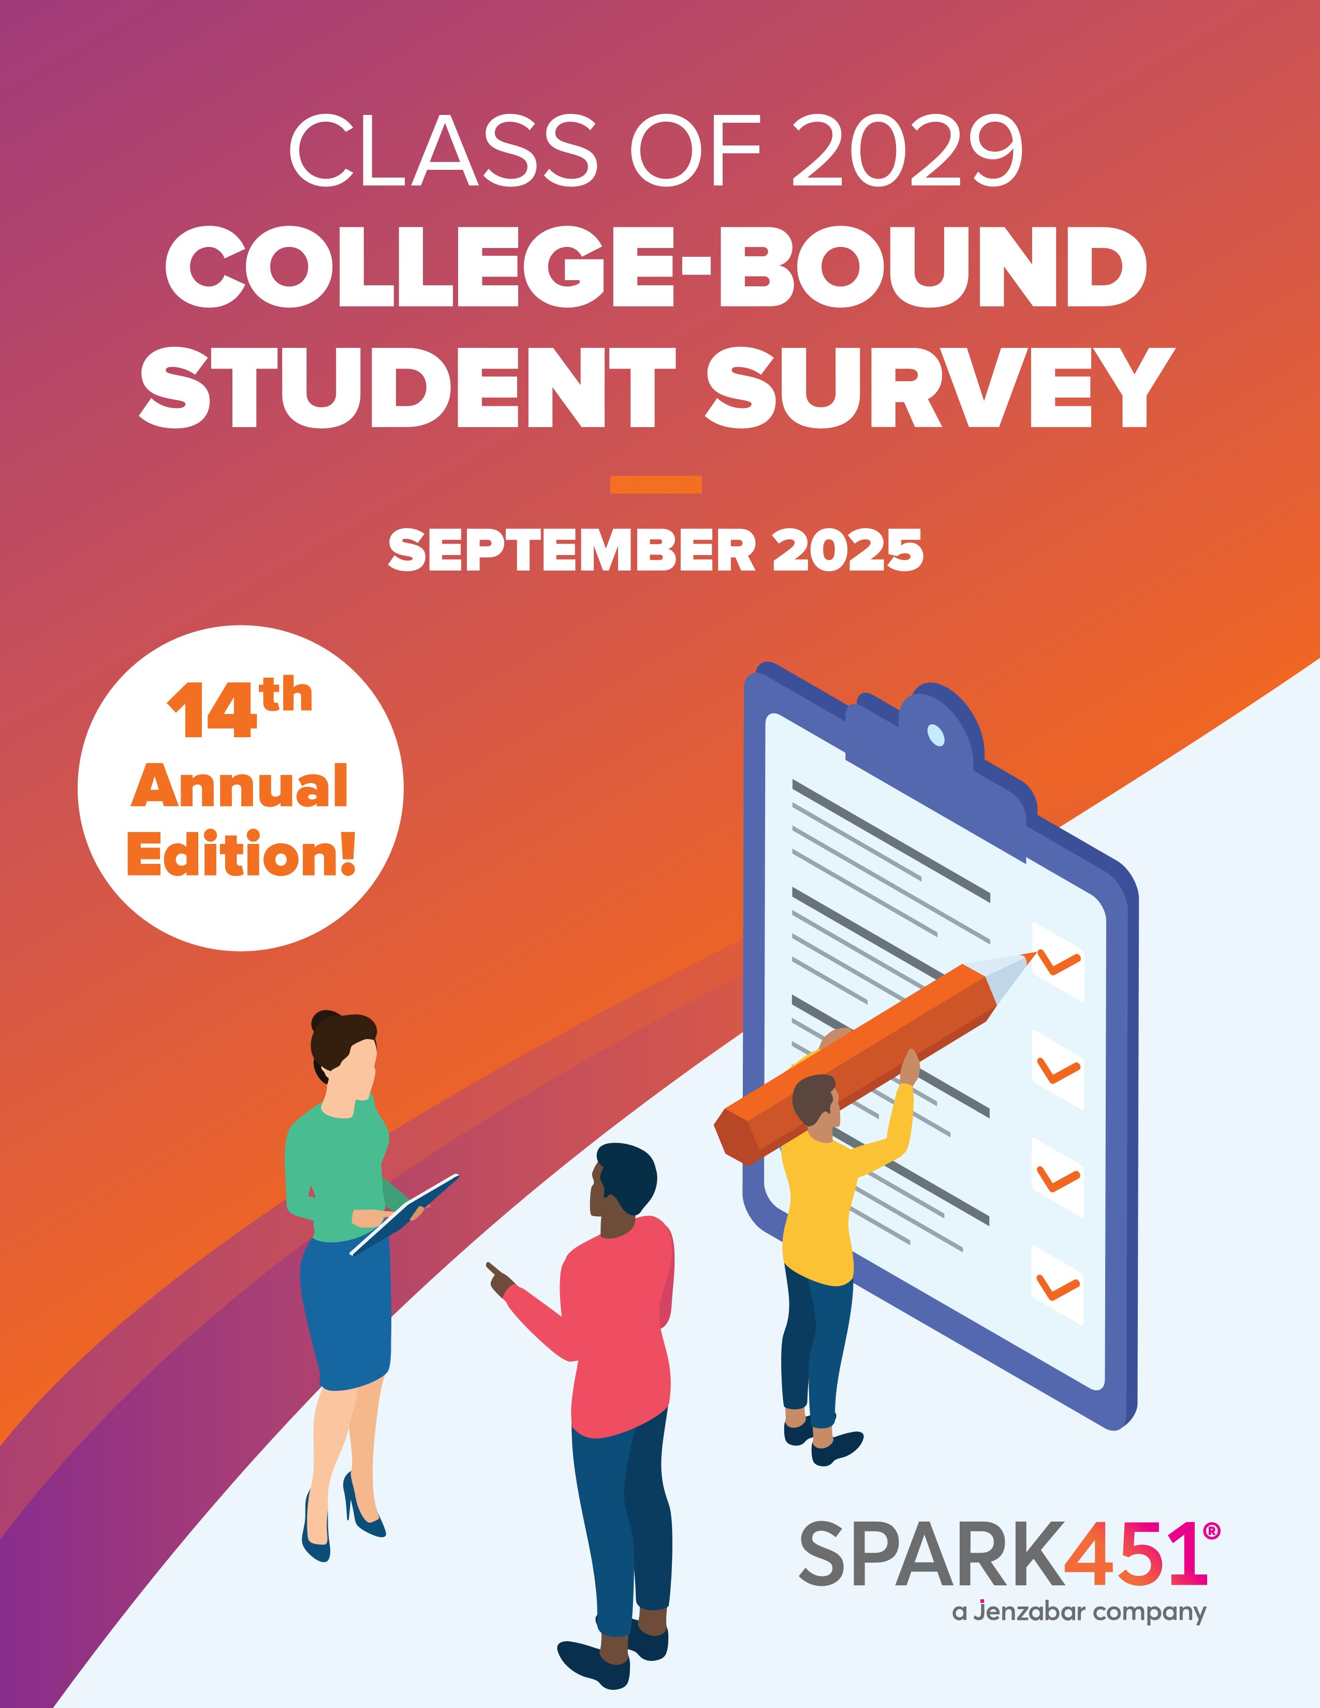
OVERVIEW
This report presents findings from a post-graduation survey administered to high school seniors, aimed at gathering feedback on their individual college search experiences. Over 1,800 respondents reported a wide range of post-secondary plans, including enrollment at private and public universities, religiously affiliated schools, liberal arts colleges, research institutions, and Historically Black Colleges and Universities (HBCUs). Some students opted for community colleges, technical schools, took a gap year, or chose to enlist in the military.

This report offers actionable insights for college marketing and enrollment leaders seeking to better understand the mindset and decision-making processes of today’s prospective students. It explores trends in social media engagement, the effectiveness of various outreach strategies, and students’ perceptions of the admissions experience. By highlighting what resonated, and, equally as important, what didn’t during the college search journey, this data can inform more strategic, student-centered approaches to recruitment, communication, and enrollment planning.

POSTING, PLATFORMS, AND PREFERENCES
For the second year in a row, over 90% of students reported spending at least one hour a day on social media, with almost 60% spending three hours or more on social media each day. When you consider the schedule of a typical high school student who sleeps for eight hours and is in school for another six, those 60% of students are spending more than a third of their free time on social media.
When asked to identify which social media channels students spend the most time on, Instagram, YouTube, and TikTok were the top three, with Snapchat falling closely behind. Not only are students spending the most time on these three platforms, but they also reported using these three as tools for their college search. 70% used Instagram to find information about colleges, 52% used YouTube, and 48% used TikTok. Only 7% of students said they did not use social media to find information about a school.
Although students are spending this much time on social media and using it to seek information during their college search, less than 40% reported seeing communications from colleges or universities through these channels.
While social media originated as a place to post about your own life and keep up with friends far and wide, there continues to be a shift away from using social media as a place to share.
Instead, it is a place to search. Almost 50% of students reported that they didn’t share any information about their college search on social media. Of those that did, they were most likely to post (in order) final college selection, acceptance letters, and scholarship offers. The key takeaway: When asked about how they sought answers for questions about a college or university, 48% said they used social media.

On average, how many hours per day do you spend on social media?
%
50
40
%
%
30
%
20
10
%
0
%
No time at all
Less than 1 hour
1
–2 hours
3
–4 hours
4
or more hours
%
60
of recent grads spend
at least 3 hours on
social media daily
POSTING, PLATFORMS,
AND PREFERENCES
Which social media channels did you utilize throughout
your college search process?
80
%
%
60
%
40
20
%
0
%
Instagram
YouTube
TikTok
Snapchat
Reddit
School
personal
social
network
Pinterest
Facebook
LinkedIn
Discord
X
previously
(
Twitter)
None
Other
Twitch
Tumblr
Christian
Social
Flickr
INSTAGRAM,
YOUTUBE,
AND TIKTOK
continue to reign as the top social
media channels used by students
during their college search
POSTING, PLATFORMS,
AND PREFERENCES
38
%
of students recall receiving
a social media ad from a
college or university
%
100
%
80
60
%
%
40
20
%
0
%
%
100
80
%
60
%
40
%
%
20
0
%
College /
University
Website
College
board
.com
Search
Engine
AI
(ChatGPT,
Claude, etc.)
Printed
publications
College
Confidential
U.S. News
& World
Report
Naviance
Social media
UniBuddy
ZeeMee
Cappex
Princeton
Review
Niche
Other
Email
Mailed
materials
Google
ads
Social
media
ads
YouTube
ads
Phone
calls
Text
messages
Video
chat
Streaming
TV ads
Streaming
audio
ads
Other
Which types of communication from colleges
did you receive during your college search?
Which of the following resources did you use
to obtain information about your preferred
colleges or universities during your search?
48
%
of respondents used
social media to obtain
information about colleges
and universities during
their search
POSTING, PLATFORMS,
AND PREFERENCES
%
82
of respondents
use iPhones
Which of the following devices do you use regularly?
STUDENTS AND SCREENS
Students are spending much of their limited free time on social media,
and overwhelmingly, they’re doing so on their phones. In fact, mobile
dominates: more students report using their phone than any other
device, with 82% regularly using an iPhone.
Given this mobile-first behavior, it’s essential to ensure that every
piece of digital communication, from emails, webpages, RFI forms,
and beyond, is fully optimized for mobile. Regular audits across
platforms can help ensure that content displays correctly and
functions seamlessly on smaller screens.
While laptops are still the second most-used device among students,
there’s been a shift in the tech landscape: tablets and wearable devices
have now overtaken gaming systems like Xbox, PlayStation, and VR
headsets in popularity.
Similarly to last year, nearly one in three students said they used an AI
tool to support their college search. What were they looking for? The top
three areas of interest included academic programs, affordability and
scholarships, and details about the application process and requirements.
100
%
80
%
60
%
%
40
20
%
0
%
iPhone
Laptop computer
(
Macbook, Dell,
etc.)
Tablet / iPad
Wearable devices
(
Apple Watch,
Galaxy Watch,
etc.)
Android
Gaming System
PS4, Xbox,
(
or VR gaming
like Oculus,
Playstation VR,
etc.)
Desktop
computer
Voice Assistant
(
Siri, Google
Voice, Alexa, etc.)
Other
CHATGPT
was the top AI tool used
by students during their
college search process
100
%
%
80
60
%
%
40
%
20
0
%
%
60
%
40
%
20
0
%
College /
University
Website
College
board
.com
Search
Engine
AI
(ChatGPT,
Claude, etc.)
Printed
publications
College
Confidential
U.S. News
& World
Report
Naviance
Social media
UniBuddy
ZeeMee
Cappex
Princeton
Review
Niche
Other
None of
the above
ChatGPT
Claude
Gemini
Copilot
Chatbot on
a school’s
website
Amazon
Alexa
Siri
Google
Home
Other
Did you use any of the following AI tools
in your college search?
Which of the following resources did you use
to obtain information about your preferred
colleges or universities during your search?
/
1
3
of students used an AI tool
to obtain information about
their preferred college or
university
STUDENTS AND SCREENS
SCHOOL
WEBSITES
were students’ top destination
for getting answers to their
questions about specific
institutions
%
60
%
40
20
%
0
%
Academic
programs
Affordability
scholarships,
(
financial aid,
loans, etc.)
Application
process &
requirements
Campus
location &
surrounding
area
General
“right fit”
recommendations
Career
outcomes
Student &
campus life
Help with
my personal
statement
Other
What types of topics did you ask AI about
during your search process?
ACADEMIC
PROGRAMS
was the top topic students
asked an AI tool about
during their search process
100
%
80
%
%
60
40
%
%
20
%
0
University
website
College
admissions
officer
Web
search
(
Google,
Bing,
Yahoo!)
School
counselor
Social
media
Current
student at
the college
Family /
friends
High
school
peers
AI tool
Teacher /
coach
Alumni
Other
Clergy
When you had questions about a college /
university, how did you seek answers?
STUDENTS AND SCREENS

CHANNELS, CHOICES, AND CLICKS
More than half of students (54%) say they seriously begin their college search during junior year. That gives them over a year to engage with schools and evaluate the flood of marketing materials they receive—and many already have strong opinions about what works (and what doesn’t). Interestingly, the timeline is starting to shift even earlier: Just two years ago, 85% of students began searching the summer before junior year or later. Now, that number has dropped to 78%, with more than one in five starting as sophomores or younger. Email remains the clear favorite for college communication. It’s the most preferred channel by far, but print (despite assumptions that it’s outdated) still holds significant value. In fact, direct mail ranks second in preference.
So what kind of print do students actually want? A simple, personalized letter. For a generation that rarely receives physical mail, something tangible and tailored stands out. But personalization goes beyond using a student’s first name. Students respond best to letters that reference their interests, like their intended major, hometown, or relevant student organizations.
When it comes to email, students are selective. The top factor influencing whether they open a message is whether they recognize the school’s name. If a college is already on their radar, they’re far more likely to engage. If not, the message is often deleted without being opened.
The second biggest reason students delete emails? A generic, impersonal tone. Customization matters, especially in crowded inboxes.
Text messaging is becoming more common in the college search experience. Today, 56% of students report receiving texts from schools, up more than 10% compared to two years ago. While only a small minority (less than 3%) say they never want to be texted, preferences do vary: about one-third say texting is okay after they’ve inquired, and another 30% are fine with receiving texts at any point.
All of these email, text, and outreach efforts ultimately point students to one place:
your website. That makes content management and accessibility critical. When students have questions, 86% say a school’s website is their first stop.
Regular audits of admissions pages are essential, but don’t stop there. Many students also rely on third-party platforms to gather information, so it’s important to keep your presence updated on sites like CollegeBoard (the second-most used source after your website), Naviance, Niche, Cappex, Unibuddy, ZeeMee, Scoir, and the Common App.

COLLEGE-BOUND STUDENT SURVEY 2025
|

%
25
%
20
%
15
%
10
%
5
0
%
%
78
of students began their
college search process
the summer entering
junior year or later
At what point in high school did you first begin
to seriously look at college materials?
Freshman
year
Sophomore
year
Summer
entering junior
year
Beginning
of junior year
End of
junior year
Summer
entering senior
year
Beginning of
senior year
Mid-senior year
or later
CHANNELS, CHOICES,
AND CLICKS
EMAIL AND
PRINT MAIL
were the top two outbound
communication methods
students preferred during
their college search
Email
Mailed
materials
Google ads
Social
media ads
(
Facebook,
Instagram,
Snapchat,
etc.)
YouTube
ads
Phone calls
Text
messaging
Video chat
Zoom,
(
Skype,
Google
Meet, etc.)
Streaming
TV ads
(
Disney+,
Hulu,
YouTube TV,
etc.)
Streaming
audio ads
music,
(
podcast).
Other
Which types of communication from colleges
did you receive during your college search?
Rank how you prefer potential schools
to communicate with you
CHANNELS, CHOICES,
AND CLICKS
97
%
of students used email
to communicate
with colleges
%
100
%
80
%
60
%
40
20
%
0
%
1
2
3
Email
Mail
Text Messaging
Phone Calls
5
Social Media
4
50
%
%
40
%
30
%
20
%
10
0
%
%
26
of students did not open
emails because they
looked generic and
not personalized
Regarding the emails you didn’t open or read,
what was the reason why you did not open it?
I had never
heard of the
institution that
sent the email
The subject
line did not catch
my attention
The layout of
the email did not
catch my attention
The email
looked generic,
like it was not sent
specifically to me
I delete all emails
if I do not recognize
the sender
I do not use an
email account
Other
CHANNELS, CHOICES,
AND CLICKS
%
31
of survey respondents
reached out to a current
student to get answers
about a school
CHANNELS, CHOICES,
AND CLICKS
%
100
80
%
60
%
40
%
20
%
%
0
University
website
College
admissions
officer
Web search
Google, Bing,
(
Yahoo!)
School
counselor
Social media
Current student
at the college
Family
or friends
High school
peers
AI tool
Teacher or
coach
Alumni
Other
Clergy
When you had questions about a college / university,
how did you seek answers?

66
%
of students say it’s okay
for colleges to text them as
early as inquiring, with 31%
saying that they are okay
with it anytime
CHANNELS, CHOICES,
AND CLICKS
50
%
40
%
%
30
%
20
10
%
0
%
Anytime
After I’ve requested

information
After I start an
application
After I’ve been
admitted
After I deposit
or confirm my
enrollment
Never
When is it okay for a college to text you?
Based on the various print materials you
have received from different schools,
which did you like most?
PERSONALIZED
LETTERS
were once again
the preferred printed
marketing touchpoints
by most college-bound
students
Letter Tailored to Your Interest
)
Major, Location, etc.
(
1
2
3
4
5
CHANNELS, CHOICES,
AND CLICKS
Swag (Sticker, Pennant, etc.)
College Overview Catalog
Foldout Brochure
Postcards
%
53
of students applied
to 10 or more schools
How many schools did you apply to?
APPLYING ON
THEIR TERMS
Up from 45% last year (and 39% in 2023), over 50% of students
applied to 10 or more schools. This explains how application
pools continue to grow despite the population shrinking.
Why apply to so many schools? Convenience is a key reason.
More than 80% of students said they found the Common Application
to be the most attractive option for applying. Cost also plays
a major role—65% of respondents applied to more schools
than they originally intended because they received fee waivers.
Lastly, the reduced number of application requirements is helping
broaden access.
Though convenience is king, the appeal of test-optional policies
seems to be declining. In 2024, 44% of respondents said a school’s
test-optional policy was a factor in applying. That number dropped
slightly to 40% this year. And while previously 50% either didn’t take
a test or didn’t submit their scores, that number dropped significantly
this year to 38%.
20
%
15
%
10
%
5
%
0
%
1
2
3
4
5
6
7
8
9
10
11
12
13
14
15
16
17
18
19
20+
65
%
of students were motivated
to apply to certain schools
because they received
application fee waivers
APPLYING ON
THEIR TERMS
Was the offer of an application
fee waiver a factor in choosing
where to apply?
NO
35
%
YES
65
%
%
100
80
%
%
60
40
%
20
%
0
%
84
%
of students found the
Common App the most
appealing way to apply
Which method do you believe was the most appealing way to apply?
Common Application
Coalition / Scoir
application
School’s online
application
School’s online
pre-populated
application
Paper application
APPLYING ON
THEIR TERMS
70
%
of students ranked the
acceptance of their high
school college credits as
important or very important
APPLYING ON
THEIR TERMS
50
%
40
%
30
%
20
%
10
%
0
%
In selecting your school of choice, how important was
the acceptance of college credit taken in high school?
Very important
Important
Not important
N/A

THE WHY BEHIND “YES”
The high school class of 2025 belongs to a generation of savvy, self-directed consumers who value authenticity and expect to find information on their own terms. When weighing college options, their priorities remain consistent: Academic quality and affordability continue to rank as the most important factors, followed closely by scholarship opportunities. Notably, campus safety made its first appearance this year as a key consideration—another reflection of how students are evaluating both fit and long-term value.
This year, we asked students about their experiences with direct admissions. One in three reported applying to at least one school through a direct admit program. However, fewer than half of those students chose to enroll at the school that admitted them directly. The takeaway: While direct admissions programs are generating interest and contributing to increased application volume, they have yet to significantly influence final enrollment decisions or class size.
Geography still plays a role in college choice, but it’s evolving. This year, 71% of students applied to a mix of in-state and out-of-state schools. Among those who looked beyond their home state, top motivators included access to specific academic programs and the desire for new experiences. Ultimately, though, nearly 60% chose to stay in-state. Still, distance doesn’t deter everyone—almost 30% of students are attending a school more than four hours from home. However, location isn’t everything. Three out of four students said that a college’s political stance would influence their decision to enroll.
Despite the rise of virtual resources, the campus visit continues to be one of the most influential moments in a student’s decision-making process. For 45% of students, visiting a campus was their first step in learning about a school, while 39% visited after being admitted. And for 25% of respondents, it was that initial visit that confirmed a school was the right fit. Among those who didn’t visit, reasons included feeling well-informed through other means, scheduling issues, or financial limitations.
How important were the following in making your college decision?
1
2
3
4
5
6
Academic Quality
Housing Availability
School Size
Cost / Financial Aid
Campus Appearance
Average Class Size
Scholarship Offer
Campus Admissions
Visit
Athletics
Campus Safety
On-Campus
Counseling Services
School’s Religious
Affiliation
Location / Setting
Diversity
Family / Alumni
Extracurricular
Activities
Proximity to Home
11
12
8
9
10
7
14
15
16
17
13
ACADEMIC

QUALITY

and

COST
were the most important
factors that influenced
students’ enrollment decisions
THE WHY BEHIND “YES”
Parent
College Admissions
Representatives
Current College Students
High School Counselor
Teacher
Friend / Neighbor
Extended Family / Relative
Alumni
Coach
How much of an impact did the following person(s)
have on your decision?
PARENTS
are the most powerful
influencers when it comes
to choosing a college
1
2
3
4
5
7
8
9
6
THE WHY BEHIND “YES”
25
%
of students knew
they’d found the
right school upon
their first visit
THE WHY BEHIND “YES”
%
50
%
40
%
30
20
%
10
%
0
%
When did you know the school you chose was right for you?
When I first visited
When I received my
acceptance letter
When I received a
scholarship / financial
aid offer
After comparing
other schools
I have not made a
college decision yet
Did you apply to any school using
a direct admit program?
Are you attending a school you were
admitted to via the direct admit program?
32
%
of students applied to
a direct admit program
they were invited to
%
41
are actually attending
that school due to the
direct admit program
NO
%
59
YES
41
%
THE WHY BEHIND “YES”
NO
68
%
YES
32
%
4+
HOURS
is the most common
distance from home
THE WHY BEHIND “YES”
%
50
40
%
30
%
20
%
10
%
0
%
How far from home is the school you chose?
0
–30 minutes
31
–60 minutes
1
–2 hours
2
–3 hours
3
–4 hours
More than 4 hours
74
%
of students reported that
a college’s political stance
would influence whether they
chose to attend that college
THE WHY BEHIND “YES”
%
50
40
%
30
%
20
%
10
%
0
%
Would a college’s political stance (e.g., DEI, climate change,
abortion, human rights, immigration, gun control, social justice, etc.)
influence whether you chose to attend that college?
Yes, and it would be a deciding factor
Yes, but it would not be a deciding factor
No, it would not influence me
98
%
of students who knew they
were attending somewhere
this fall made their final college
decision by the time they
completed the survey
in summer 2025
LOOKING FORWARD
98
% of survey responders had made their college decision by the time
they took the survey this summer—94% of whom are heading to higher
education. The others have chosen to join the military or workforce,
some are taking a gap year and some plan to enroll in the spring.
Though the tools and trends of a student’s search process may shift
slightly from year to year, the core of it remains the same: They have
access to an incredible amount of information online and therefore
expect that any information sent directly to them is not the same as
what they can find on their own. Luckily, 70% of students reported
being satisfied with their admission process this year—an increase
from 62% in 2024. That speaks to the hard work and dedication that
our industry puts into helping each and every student find their right fit.
At this time, have you made your final decision
as to which school you will be attending this fall?
NO
2
%
YES
98
%
70
%
of students were satisfied
to extremely satisfied with
the admission process
%
50
40
%
30
%
20
%
10
%
0
%
How satisfied were you with the admission process?
Not Satified
2
3
4
Neither satisfied
or dissatisfied
6
7
8
Extremely
Satified
LOOKING FORWARD

ABOUT SPARK451
Spark451, a Jenzabar company, is a higher education
enrollment strategy, technology, and marketing firm that
combines creativity with powerful technology to achieve
measurable results. With a mission to help colleges and
students fuel their future, the firm integrates a multitude
of communication channels and platforms for effective
enrollment marketing, student search, creative services,
and digital media. Since 2011, Spark451 has worked with
over 200 colleges and universities nationwide.
Spark451.com
connect@spark451.com
516.442.4650

